Audition Information
In this packet you will find the audition etudes required for next school year’s ensemble/class placements. This is only relevant to wind students, not percussion or guard. The audition wills be held for current PSLHS Band students on Thursday May 17th, and Friday May 18th during classes. A schedule will be published as we get closer. Incoming freshman (current 8th graders) will audition for Mr. Wiley at their middle school on a day determined by their current band director.

The audition will be as follows:
- Required Etude
- Major scales chosen from the following
  - C, F, Bb, Eb, Ab, Db, Gb, G

This audition will determine which concert band class you will be placed in. The ensembles available will be the Wind Ensemble (6th period) and the Symphonic Band (3rd/4th period). Symphonic band brass and woodwinds will be split up between 3rd and 4th period. You will be placed in your ensemble based on your audition.

If you have any questions, please speak to Mr. Wiley

PSLHS Band Winds Audition Packet
(2018-2019)
Flute 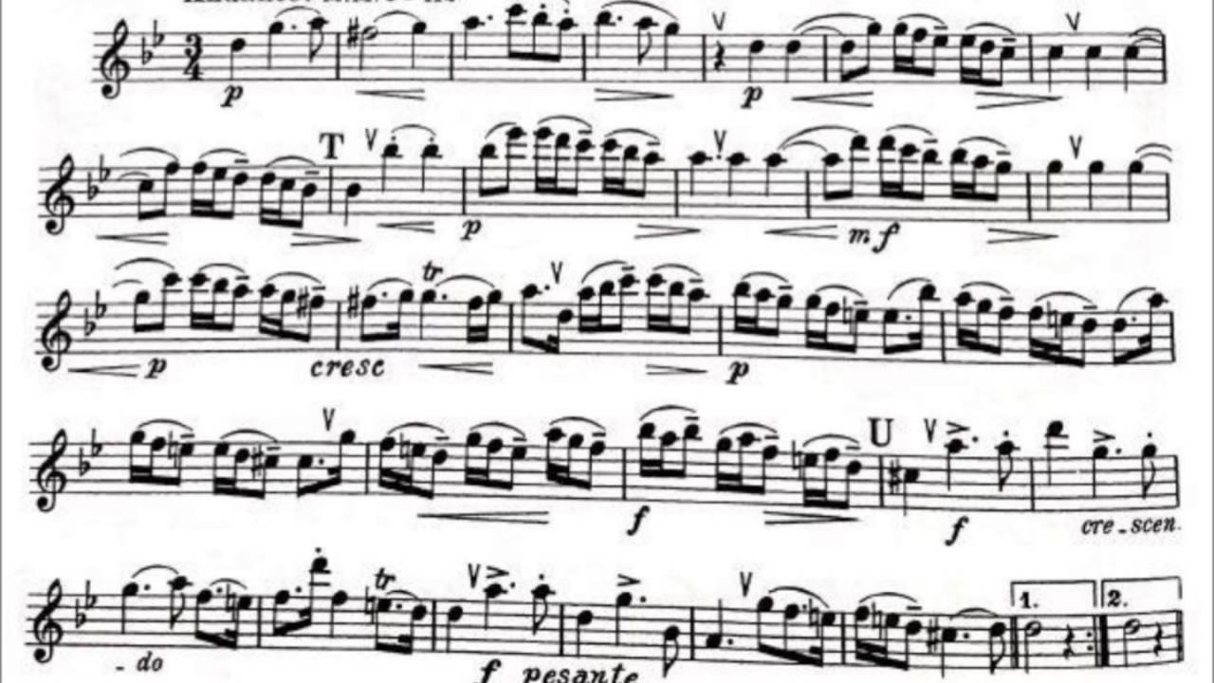
Bb Clarinet
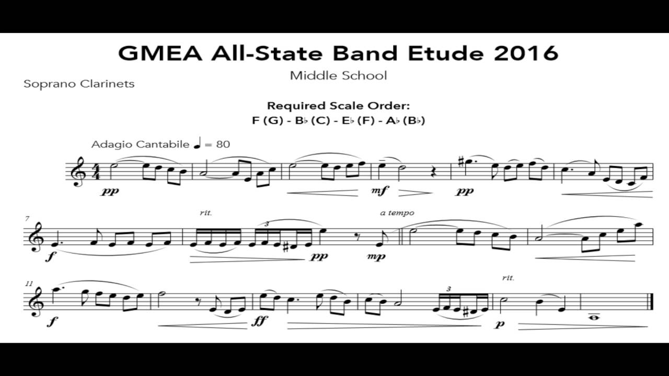
Oboe
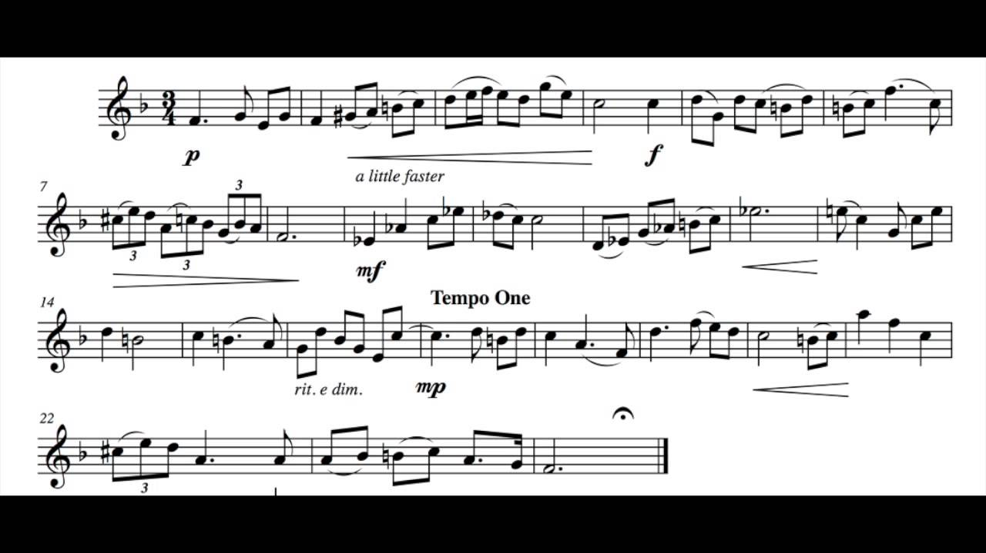
Bb Bass Clarinet
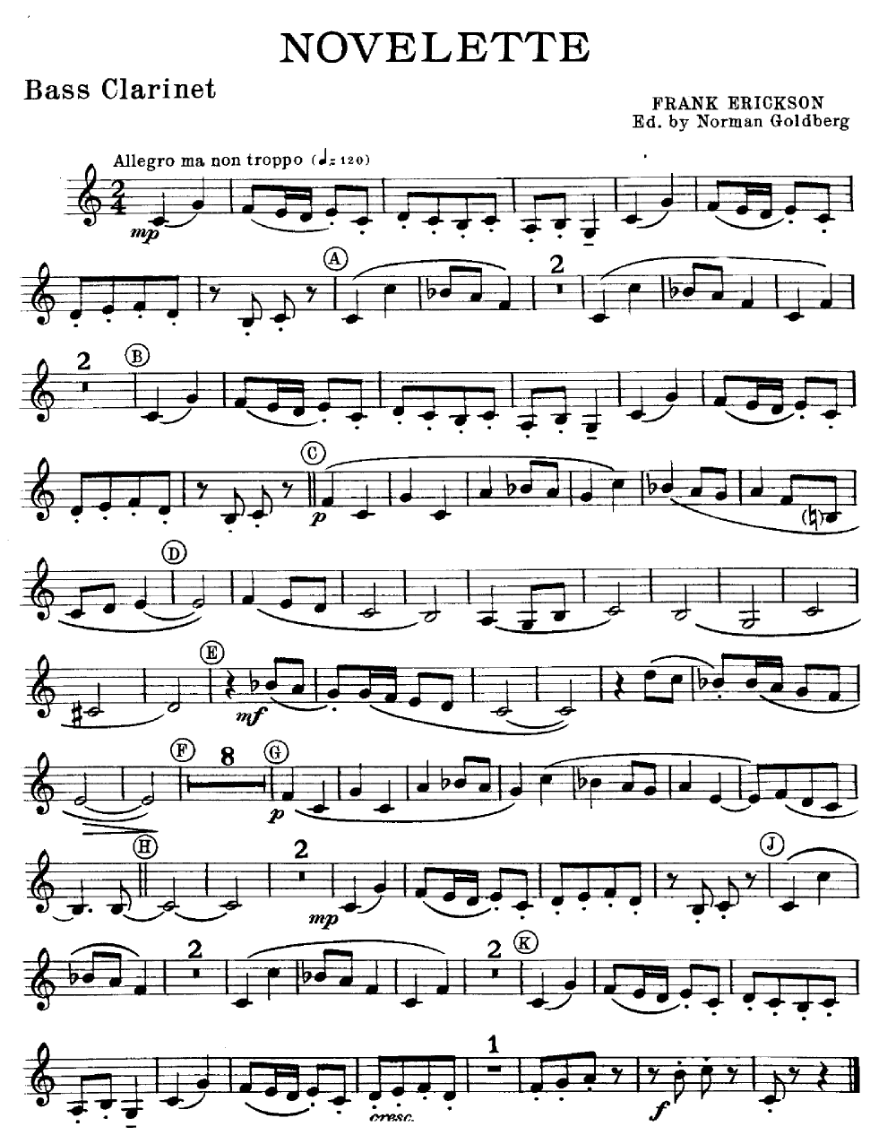

Bassoon
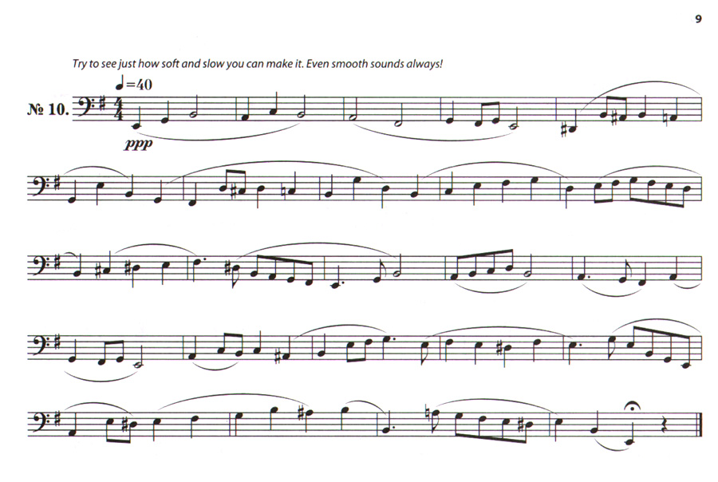
Alto Saxophone
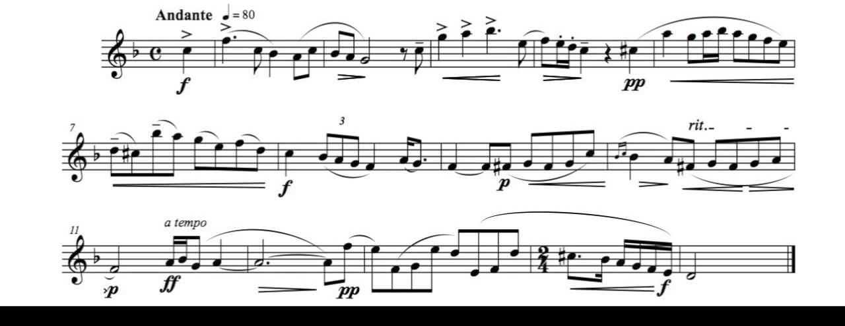

Tenor Saxophone
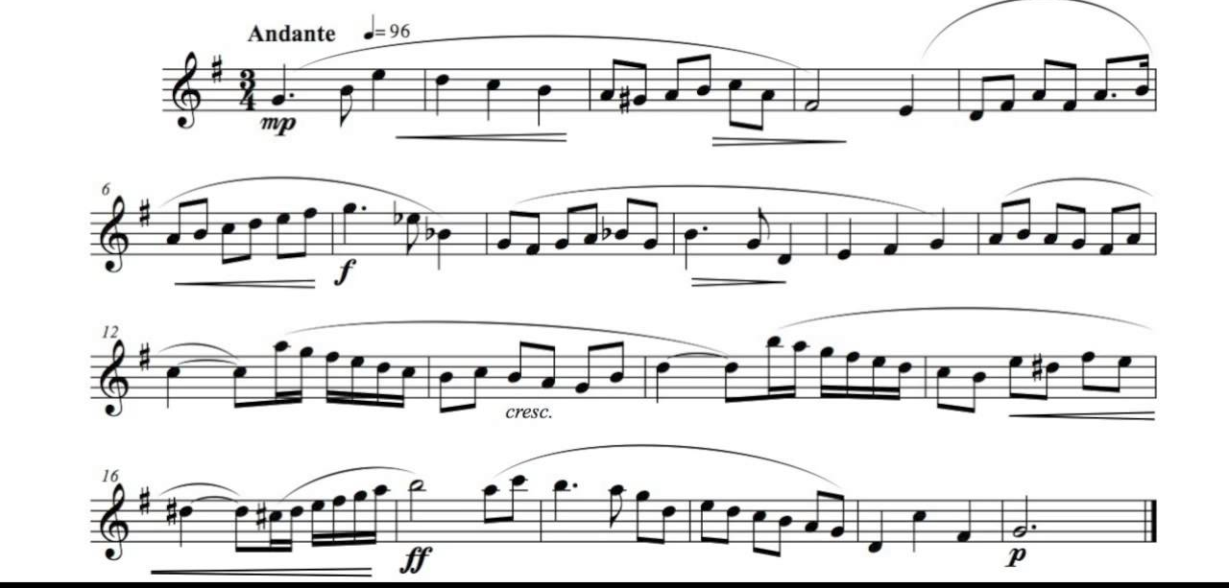
Baritone Saxophone
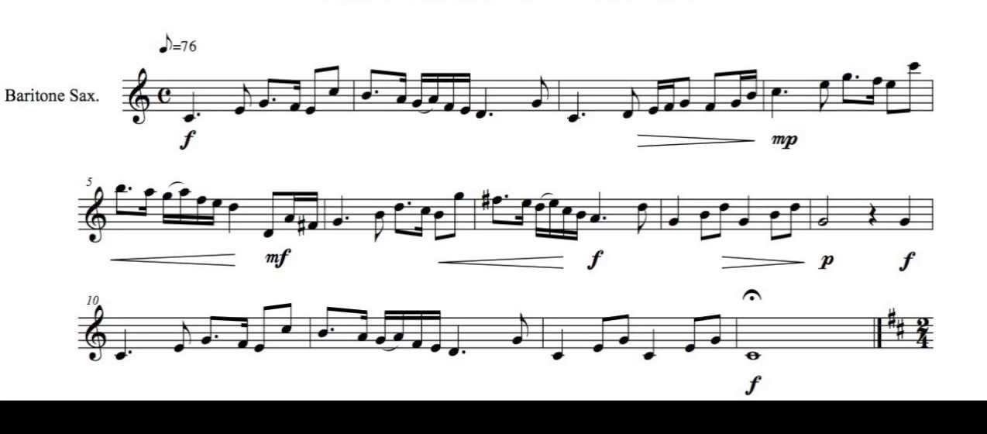

French Horn
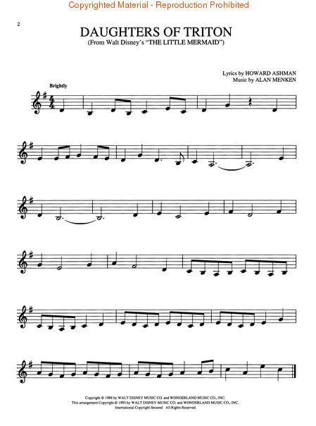
Trumpet
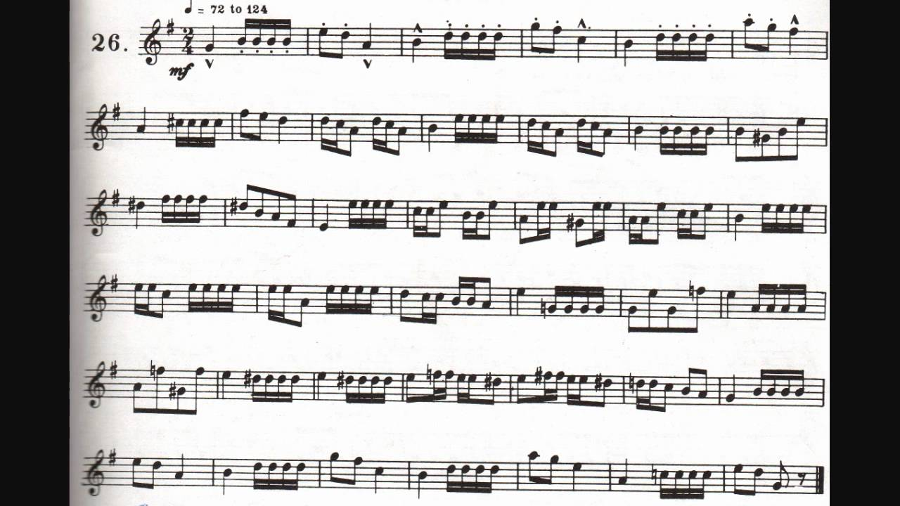
Trombone/Baritone
Tuba

