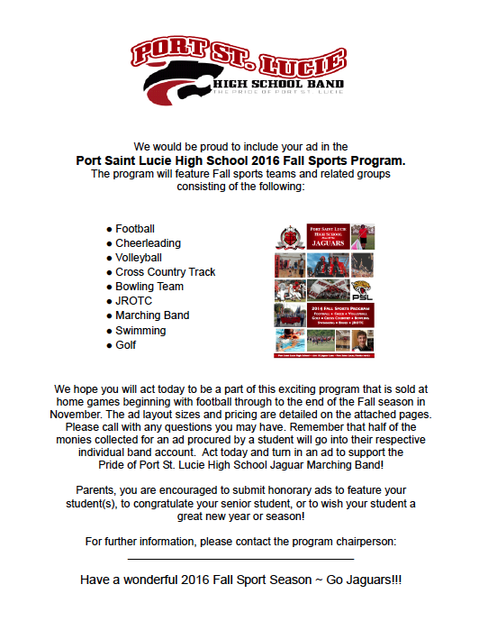

Have a wonderful 2019 Fall Sport Season ~ Go Jaguars!!!

**2019**

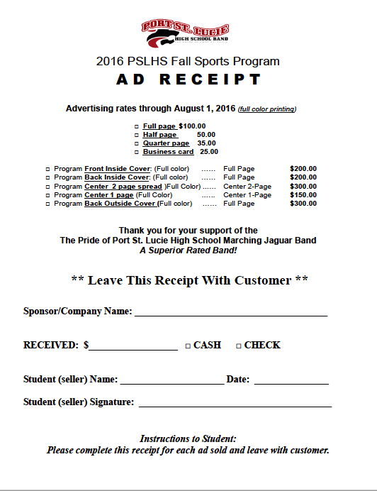

**Advertising through August 23, 2019**

**2019 PSLHS Fall Sports Program**

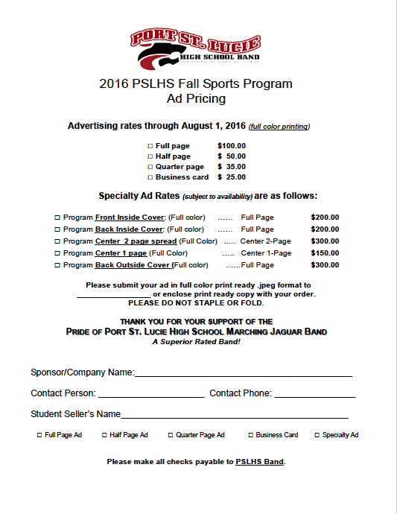

2019 PSLHS Fall Sports Program

Ad Pricing

**Advertising through August 23, 2018**

