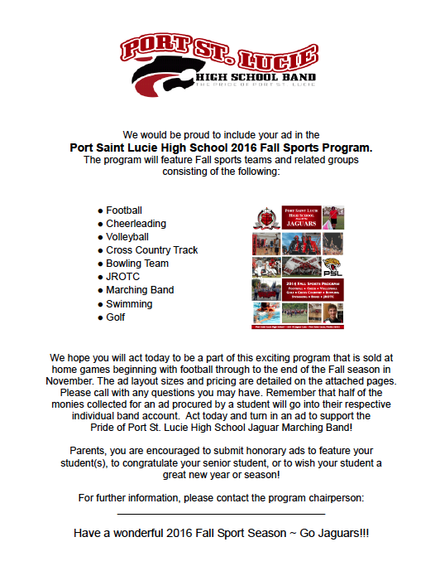

Have a wonderful 2018 Fall Sport Season ~ Go Jaguars!!!

**2018**

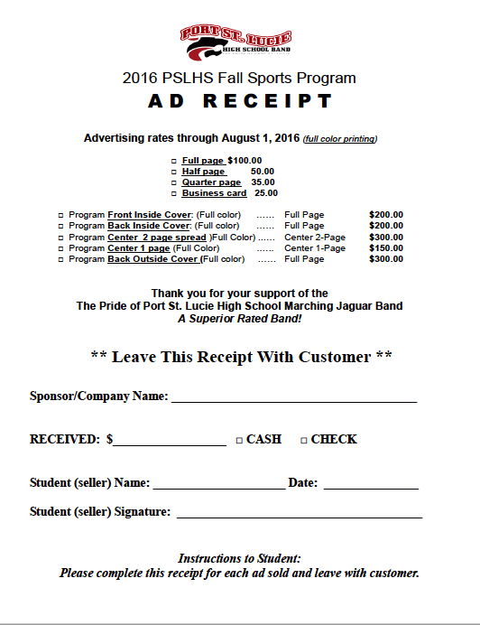

**Advertising rates through August 3, 2018**

**2018 PSLHS Fall Sports Program**

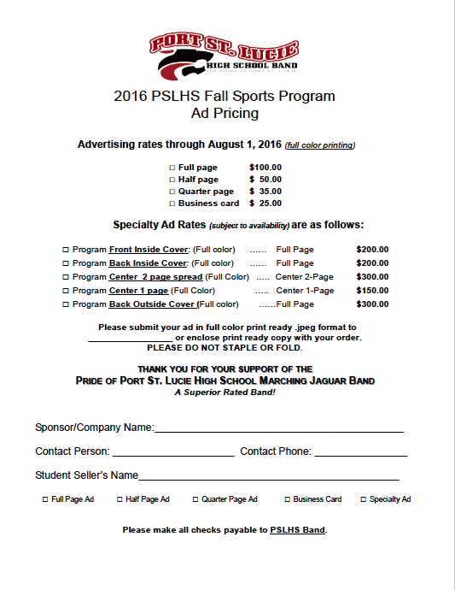

2018 PSLHS Fall Sports Program

Ad Pricing

**Advertising rates through August 3, 2018**

